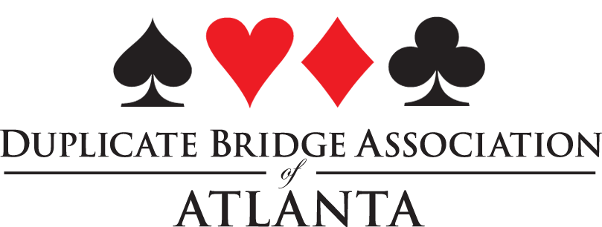Approved

DBAA/ Unit 253 Board Meeting
January 22, 2022 9:30 am via Zoom

Officers: Marty Nathan, Linda Hagood, Jane Melby, Denise DeAngelo,
Unit Reps: Becky Butler, John Simms, Melissa Taylor, Jack Feagin

Marty Nathan called the meeting to order.
Old Business
Denise DeAngelo made a motion to approve the minutes of the January 8, 2021 board meeting. Approved.
Committee Reports
The DBAA Game Club Manager is Marty Nathan. The game is currently not being held due to COVID-19.
District 7 Report – Jack Feagin
The number of DBAA representatives to the District 7 board has been reduced from 6 to 3. If a board member cannot attend a meeting, they can appoint a person to represent them at the meeting.
The GNT games are being held face to face in May 2022. Because of the COVID 19 pandemic, players do not need to prequalify for the event.
The District 7 publication is now online and emailed to members.
The DBAA newsletter will not continue
DBAA needs a chairperson for the following committees:
Awards, Change of Rank, Directory, Education, Membership and NABC.

New Business
Marty Nathan made a motion to fund the Georgia Tech Bridge Club in the amount of $500.00 as requested by a letter dated 11/9/2021. Approved.
Marty Nathan made a motion to reimburse the ACBL 25% of the local NABC 2023 budget subject to joint approval by the DBAA and District 7. Approved.
Jack Feagin made a motion to extend the terms of the current DBAA board member, due to the unusual circumstances with the COVID-19 pandemic, to the 1st sectional tournament of 2023. The elections at that time will be for a one-year term. Approved.
Sherry Lautares has moved and resigned from the DBAA board.

The meeting was adjourned.

Respectfully submitted,

Denise DeAngelo, Secretary DBAA

